SOFTWARE MANUAL FOR webAKT
Part 2: Creating and Editing an AKT Knowledge Base

This is Part 2 of the webAKT Manual. The first part – Inspecting a Knowledge Base – is in the form of a tutorial taking the reader through the tools available for displaying the various components of an AKT knowledge base, such as statements and sources,

This part assumes you have familiarized yourself with these tools, and now wish to learn how to build a new knowledge base and/or edit an existing one.

Introduction

webAKT provides an environment for the creation of a knowledge base, by allowing you to enter, view and edit knowledge, as well as enabling automated reasoning with the contents of the knowledge bases created.

Each knowledge base created with webAKT includes the following information:

- the unitary statements

- source details for each statement

- lists of formal terms, their definitions and synonyms

- object hierarchies developed for organising objects into categories

- topics, defined in terms of specific search requests
- topic hierarchies developed for organising topics into categories

- full information about the structure and content of any diagram sets in the knowledge base

Each knowledge base created is stored as a JSON text file, which is loaded into and saved from webAKT using the File menu, and inspected using the KB menu. This file is saved locally in the background whenever you make any change, so you should never lose any changes, and re-loaded automatically when you return to webAKT.

Getting started

Using a web browser, go to http://dev.webakt.org/msc2/webakt.html.

A large blank window appears with the main menubar in the top left-hand corner, as in Figure 1.



Figure 1. The main menubar

You will see the following menus in the menubar:
The File menu: This is concerned with creating a new knowledge base, and opening and saving an existing knowledge base
The KB menu: Contains commands for working with a specific knowledge base, such as listing out the statements, sources etc.
The Diagram menu: For viewing and working with diagrams reflecting networks of causal relationships.
The Tools menu: For accessing various tools for analysing a knowledge base, or comparing two knowledge bases.

[For AKT5 users: In AKT5, the commands for working with files were actually included in the KB menu, and the File menu did very little. In webAKT, these file-handling commands have been moved into the File menu, in keeping with common practice adopted by most document-handling applications.]

The File menu
Move the cursor arrow to File and click on it. The following menu appears (Figure 2):

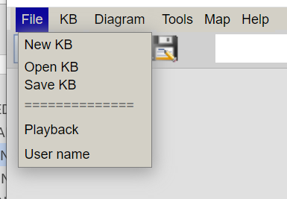

Figure 2 The File menu

When you use webAKT for the first time, a knowledge base must be opened before work can begin. You currently have 3 options for doing this:
- New: create a new knowledge base;
- Open: open a knowledge base from an existing file on your computer;
- Open sample KB: open the sample knowledge base that comes built into webaKT (the Atwima knowledge base).
In future, you will be able to open a knowledge base stored anywhere on the internet.

On subsequent occasions on the same computer, webAKT will automatically load the most recent state of the one you have been working on last, on the reasonable assumption that you will probably want to carry on working on it.

Other file management options allow the current file to be closed (Close), or the file to be saved (Save as) ,either with the same or a different name. (Note that, for web security reasons, there is no simple Save option, so you must specify where you want the knowledge base to be saved each time.)

Note that several knowledge bases can be open at the same time, with one being the currently-open one. This is the last one opened, unless you deliberately switch knowledge bases using the Select KB command.

As in AKT5, there will also be the option of saving all the information about one topic as a separate knowledge base (Save Topic as KB in the File menu), but this is not yet implemented.

File > New: Starting a new knowledge base

Select New from the File menu. The knowledge base is given the name newkb1 as a placeholder, until you save the knowledge base to a file. Then its name will be the same as the name of the file you save it in. [This is a radical departure from the way that AKT5 treated knowledge base names, but is consistent with the way that most computer applications handle naming.]

In the save-file dialogue window, move to the folder (directory) where you want to save the knowledge base, enter a name, and press Save. You will then return to the main menu as in figure 1 only now the name of the new knowledge base will appear in the top of the webAKT window.

File > Open: Opening an existing knowledge base

If you are opening an existing knowledge base, select File > Open. Once you have selected the knowledge base file and pressed Open you will return to the AKT main menu with the name of the knowledge base at the top of the main webAKT window. Simultaneously, a Metadata panel appears on the screen, designed to give a brief introduction to the selected knowledge base they have selected. You can edit this information if you want (in which case click on the Update button when you are done), or simply click the close button (X) at the top-right of the panel.

File > Save: Saving the current knowledge base

Select File > Save as to save the current knowledge base. (You can have multiple knowledge bases loaded into webAKT at the same time, but only one is the “current knowledge base”, possibly selected using the File > Select KB command.)

It is a good idea to save the knowledge base as soon as you have created it, since this gives you the opportunity to name it, as the knowledge base’s name is the same as the file name.

As noted previously, web applications do not allow, for security reasons, the use of a simple Save operation (i.e. saving information to a local file without going through a Save File dialogue). However, every change you make to a knowledge base causes the whole knowledge base to be saved in the browser’s cache, so you are protected against loss of work in the event of a power cut or some other incident.

Collection | Listbox | Buttons | Details panel | Links to
Statements | Statement id  Formal  English | View  New  Edit |  | Sources  Formal terms
Sources
Formal terms
Object hierarchies
Topics
Topic hierarchies
Images

The KB menu

The main purpose of the KB menu is to allow you to view the various types of information that together constitute the knowledge base. Every command in this menu operates on the currently-active knowledge base, whose name is displayed to the right of the menubar. This includes collections of things, like statements, sources, formal terms and hierarchies.

This menu also includes a command, View JSON, for displaying the complete contents of the knowledge base in its raw form, though this is unlikely to be of useful for the average user.

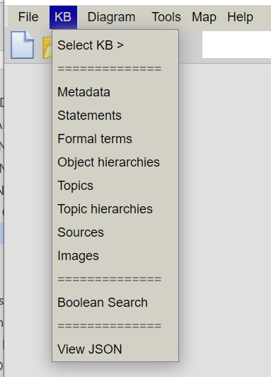

KB > Summary: Displays summary statistics about the knowledge base, such as number of statements and sources.
KB > Metadata: Displays metadata about the knowledge base, provided by the knowledge base creator, such as a brief description and information about the location.
KB > Statements: Tabulates the statements in the knowledge base, as a scrollable table.
KB > Sources: Tabulates the sources for the statements in the knowledge base, as a scrollable table.
KB > Formal terms: Tabulates the ‘formal terms” (i.e. the terms nouns used in statements), as a scrollable table.
KB > Formal term hierarchies: Tabulates the hierarchy/ies used to group formal terms into meaningful clusters.
KB > Boolean search: Allows the user to search for statements that contain various combinations of formal terms.
KB > Topics: Tabulates the various named search expressions (“topics”) developed by the knowledge base creator.
KB > Topic hierarchies: Tabulates the hierarchy/ies used to group topics into meaningful clusters.
KB > Images: Displays thumbnail sketches of the images available for display alongside other information.

Each of the above commands in the KB menu displays a panel (typically called a dialogue window in AKT5) showing the corresponding items. Each panel provides buttons for creating a new item of that type, for displaying or editing the details for one instance, or for deleting one instance. So, we talk about having a Statements panel displaying all statements in a knowledge base, and a Statement Details panel for displaying information about a particular statement. Similarly, a Sources panel and a Source Details panel, etc.

There is a marked difference in behaviour between AKT5 dialogue windows and webAKT panels. The former can only have one instance of a particular type of dialogue window (for example: a statement details window) on the screen at one time. In webAKT, you can have multiple instances of a particular type of window. So, you could have two Statements panels, showing the statements for two different knowledge bases. Or, two Statement Details panels, for two different statements, allowing them to be compared side-by-side.

KB > Summary: Summarising the contents of the knowledge base

This command, new to webAKT, in the KB menu provides a quantitative summary of the various components of the knowledge base – for example, the number of statements and sources. The headings are the same as in the KB menu itself, and each heading provides a link to the same Panel accessed through the KB menu.

Like many other panels, this panel is “live”, meaning that it updates automatically whenever the knowledge base is changed, for example by adding a statement.

Figure XXX shows a sample of the scrollable panel.
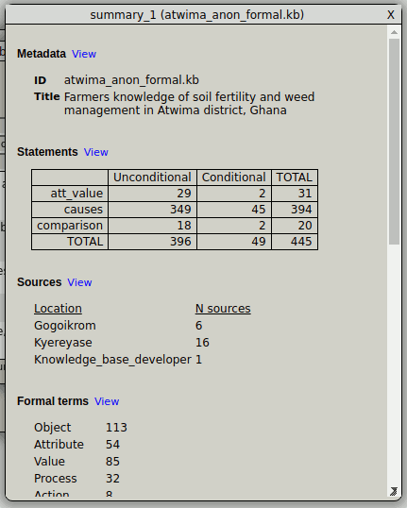

KB > Metadata: Viewing and editing the knowledge base metadata

When creating a new knowledge base, or opening an existing one, the Metadata panel appears automatically. It can also be accessed by selecting Metadata in the main KB menu.

The Metadata panel serves as an introduction to the knowledge base. The reason it appears as you open the knowledge base is to give users, other than the knowledge base developer, an immediate general understanding of the knowledge base, thus facilitating access to and manipulation of that knowledge.

The Metadata panel, like all other panels in the webAKT desktop, can be closed by clicking the X button in the top-right of the panel.

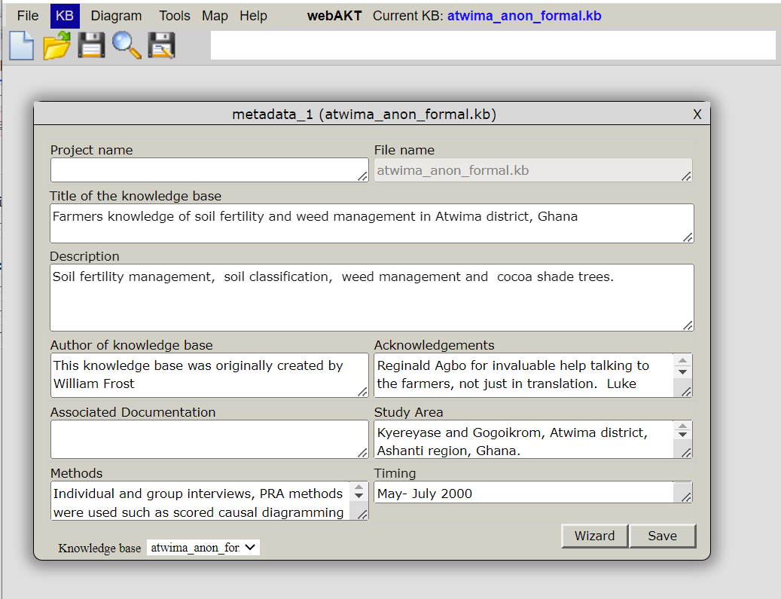
Fig. XXX The Metadata panel

Each section of the Metadata panel (Fig. XXX) is self explanatory:

- Title of this knowledge base: – Here the full title of the knowledge base should appear, for example, the full title of the ‘treefodd’ knowledge base is ‘Tree Fodder and Indigenous Knowledge in Nepal’.

- What the knowledge base is about: – Here the area of local knowledge covered by the elicitation process should be described.

- This knowledge base was developed by:– Here the name of the knowledge base developer(s) is(are) recorded.

- Acknowledgements: here all acknowledgements are listed – to those, other than the developers, who assisted in the design and creation of the knowledge base and to any funding bodies that supported the project.

- Purpose - If the knowledge base was built as part of a particular project, or designed to supplement work in a certain field, this can be recorded here.

- Methods – Here information about the methods used for selecting the interviewees and collecting the knowledge may be described.

- Location – Here information about the exact location of the communities visited can be recorded.

- Timing of Knowledge Collection – The time of year, and the season that the knowledge collection was undertaken, may influence the knowledge elicitation process and should therefore be noted.

- General Comments – Here any other pertinent pieces of information may be recorded.

When you create a new knowledge base, you should enter details in the relevant boxes, then click on the Update button. If you are looking at a knowledge base that you have loaded from a file, or accessed over the internet, you can edit the data, which will then be saved in your local version of the knowledge base file when you click the File > Save as… option.

KB > Statements: Viewing, creating and editing statements

The core of an AKT knowledge base is its collection of statements. This section describes the user interface in webAKT for entering new statements, and for viewing and editing statements. It does not go into the rules for formulating statements according to the AKT grammar: that is quite involved, and is covered in a separate document.

Having said that, webAKT does provide a “wizard” to make it easier to formulate statements, in the form of a set of templates matching AKT’s statement grammar, with slots for particular nouns in the statement. This accessed via the Template button in the panel used for creating a new statement. So even if you have not acquainted yourself with AKT’s grammar, you can still get started by entering made-up statements which are syntactically correct (i.e. which conform with AKT’s grammar), to familiarise yourself with the procedure for entering statements.

Displaying all statements
The statements in the knowledge base are displayed in the Statements panel, which is invoked using the KB > Statements command. If you are starting a new knowledge base, this panel will be empty as in Figure XXX. If you are adding statements to an existing knowledge base, the statements previously entered will be listed in the ‘All Statements’ listbox as in Figure XXX.

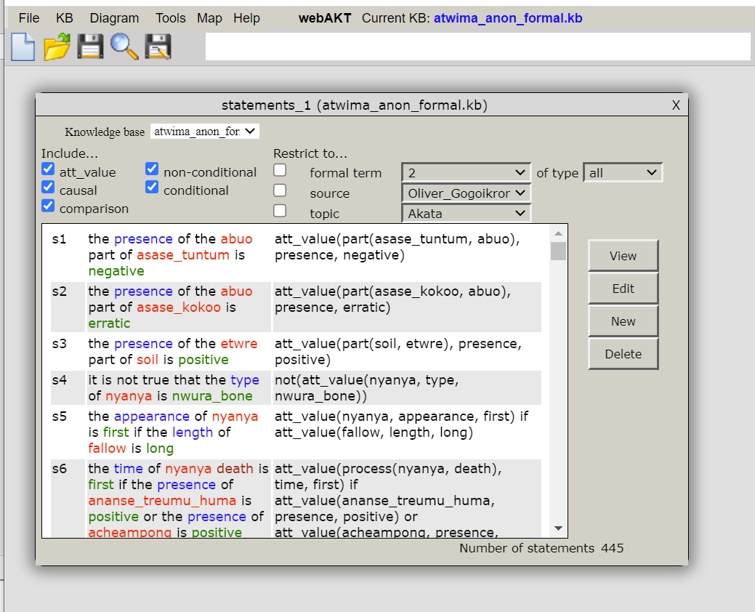

The information shown in this listbox is customizable. Currently, it shows the statement ID, and the formal and quasi-English versions of each statement. This will be extended with options to allow the user to choose which properties of each statement should be displayed.

Filtering the statements
webAKT provides a simple yet powerful method for filtering the statements (i.e. selecting a subset of them according to user-defined criteria). This makes use of the 8 checkboxes at the top of the panel.

Five checkboxes relate to the type of statement, and statements are included if the corresponding checkbox is ticked. The types are:
- att_value, causal or comparison statements; and
- non-conditional or conditional statements.

Three of them relate to particular properties of the statement, and statements are restricted to those that satisfy the specified criteria. The three criteria are:
- containing a specified formal term;
- provided by a specified source; and/or
- relevant to a specified topic.
If one or more of these checkboxes is left unchecked, then that criterion does not apply.

Note that the filtering is applied immediately, as soon as you check or uncheck a checkbox, or change the specified restriction value.

Working with individual statements
The Statements panel provides 4 buttons for working with individual statements:

- New: Opens up a new panel for entering a new statement;
- View: Opens up a new panel for viewing (read-only) the details of a selected statement. The statement must first be selected from the listbox.
- Edit: Opens up a new panel for editing the details of a selected statement. The statement must first be selected from the listbox.
- Delete: Deletes a selected statement. The statement must first be selected from the listbox.

The first 3 open up the same panel type – a ”statement_details” panel. The exact contents of this panel depends on which mode (new, view or edit) you choose.

The following sections detail how to work with each option.

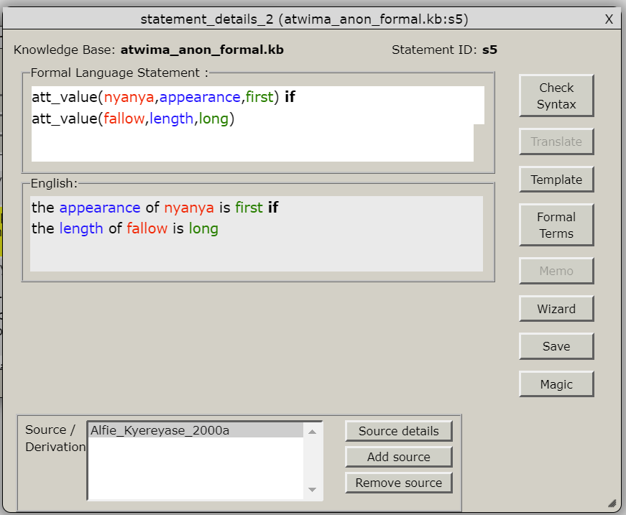

Creating a new statement

In order to enter a new statement select New in the Statements panel

Figure 7.11 is an example of a newly entered statement.

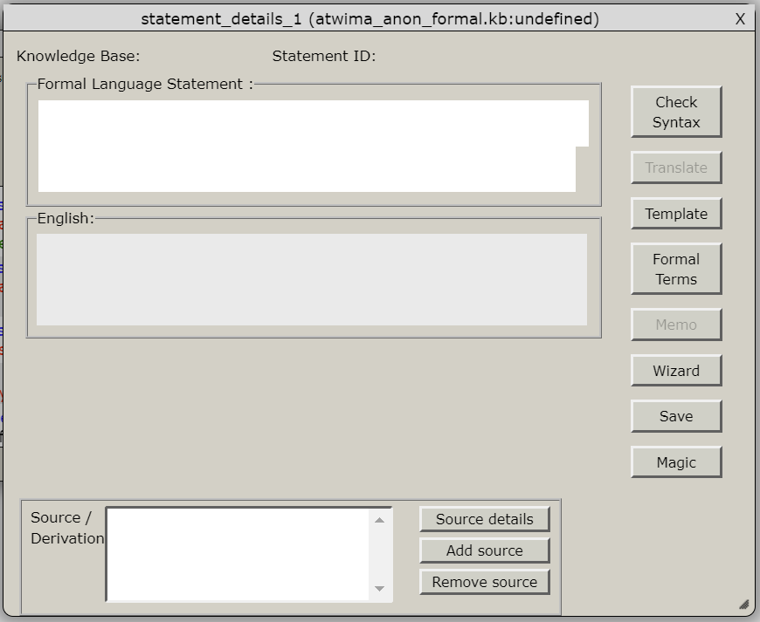

Figure 7.11 The ‘New Statement’ dialog box

All unitary statements have to be entered using the formal language (AKT Manual, Chapter 4.2), in the ‘Formal Language Statement’ box. As you type the statement, the syntax of the statement is checked character-by-character. If it is incomplete or incorrect, then a red bar appears at the right of the edit box. If the statement entered so far is syntactically correct (according to the AT grammar), then the bar changes to green.

Note the statement may be syntactically correct even if you have not finished it, e.g. if you are going to add a conditional clause (starting with “if”) after the main part of the statement.

The formal statement must conform to the grammar described in the AKT Manual, chapter 4.2. If you receive any error messages then either the structure of the statement does not conform to the formal grammar, or one of the reserved terms (e.g. att_value) is misspelt.

Translating the statement into English
Once the formal language statement has been correctly entered, select Translate from the ‘New Statement’ dialog box for a natural language translation of the formalized statement. The natural language statement generated (Figure 7.14) will be stylised and will not always read smoothly or be grammatically correct. It should, however, make sense and express the meaning of the unitary statement unambiguously.

Figure 7.14 Translation of the formal statement into natural language

Adding the statement to the current knowledge base
When you are satisfied with the statement, press Update. Please note that this only updates the current knowledge base in the webAKT application. The programme automatically adds it to the updated ‘Statements’ panel (Figure X) from which all existing statements can be accessed. To save it in the knowledge base permanently you must select Save as under the File menu.

Linking words in the statement to the glossary of formal terms
If your statement includes any formal terms new to the knowledge base, webAKT will automatically determine the type (grammatical role) of the formal term from its position in the statement, and will automatically create a new formal term with this name and type. [Note: AKT5 asked you to confirm that you want the new formal term(s) to be created – I will add this in at a later date.]

Associating a statement with one or more sources
In webAKT, you may, but do not have to, associate a statement with a source when you create the statement. This is a marked departure from AKT5, where you had to do this with one source before you could add the statement to the knowledge base. (If you wanted to include more than one source, you had to do that as a separate operation.)

The reason for this decision is to avoid interrupting the flow of adding statements by forcing the knowledge base creator to divert and create a new source. Sources can always be added afterwards, and indeed webAT easily allows you to find all statements that do not have a source specified.

If you do not like this approach, then you can always add information about your sources first: then associating them with a statement is easy. (Alternatively, you can complain, and webAKT can be changed to emulate the AKT5 behaviour.)

To add associate a statement with a source that already exists, click on the Add source button. If the Sources panel is not already open, then it will appear. Then click on the relevant entry in the Sources panel listbox, and it will be added in the Source listbox for this particular statement. You can then click on additional sources if they have also expressed this statement.

To detach a source from a statement, click on the Detach source button, then click on the relevant source in the Sources listbox for this particular statement (not in the listbox in the main Sources panel).

Viewing a statement

See first tutorial.

Editing an existing statement

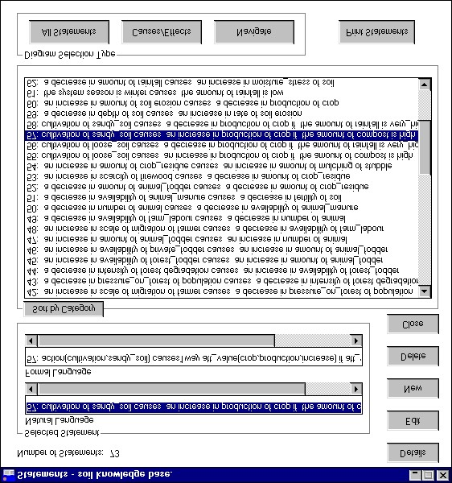

Figure 7. 15 ‘Statements’ dialog box

will appear (Figure X), requesting information on the ‘Information Source’.

The following will be handled in the KB > Sources section. Just make a brief reference to it here.
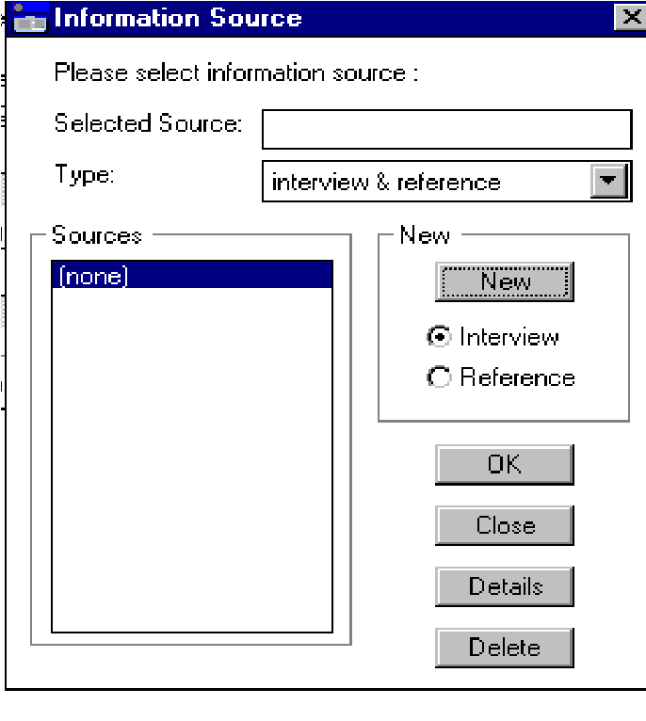

Figure 7.7 Information dialog box

Deleting a statement

In order to delete a statement, enter Statements via the main KB menu and highlight the statement you wish to delete. The statement will appear in the ‘Selected Statement’ box. Then press Delete. A message will appear, giving the natural language translation of the statement to confirm whether you really want to delete that statement (Figure 7.24).

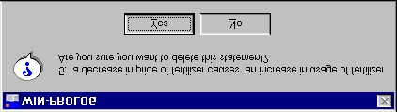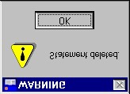

Figure 7.24 Message requesting you to confirm whether Figure 7.25 Message you wish to delete the highlighted statement confirming that the statement
has been deleted

If Yes is selected, another message appears (Figure 7.25) confirming that the statement has been deleted.

If you wish the statement to be permanently deleted from the knowledge base, you must save the knowledge base after deleting the statement.

WARNING
Any formal terms associated with the statement will be deleted unless they are also used in other statements.

KB > Sources: Viewing, creating and editing sources

Statements need to be attributed to one or more sources. A source might be an individual, making a statement during an interview; or it could be a published source, such as a journal paper. B attributing statements in this way, it becomes possible to explore the relationship between an individual source and the statements they make, to check for consistency between sources, and so on.

webAKT allows you to show all the sources in a table format. This can include other properties of a source, such as their location and age. This is useful for simple display purposes. It also serves as a selection list, to enable you to select a particular source and get more details about it.

As mentioned above, AKT5 obliged the knowledge acquisition person to associate a statement with a source, in order for the statement to be added to the current knowledge base. webAKT removes this obligation (though this decision could be reversed if required), but does allow th euser to identify all statements that have not as yet had a source attached to them

Displaying all sources

KB > Sources displays a panel listing all the sources in the knowledge base. If this is a new knowledge base, the list will be empty (Figure XX). Otherwise, the list will show the short ID for each source, plus additional information (Figure XX).

This panel provides the following buttons:
New: to enter a new source;
View: to view a source selected from the listbox without being able to edit it;
Edit: to edit a source selected from the listbox;.
Delete: to delete a source.

The first 3 of these display a panel, the source_details panel, which is customised according to the needs of each of the 3 modes.

Creating a new source
Clicking on the New button in the Statements panel displays a panel with fields for the various properties of a source. If this is the first time you open it up during the current session, then all fields are empty. Otherwise, some fields are pre-filled with information entered previously, such as year and location, on the grounds that this information is likely to be the same (though it can of course be edited in the normal way).

Once you are satisfied that you have entered the source details correctly, click the Update button to add it to the current knowledge base. This will close the panel, and the new source will appear in the list of sources in the Sources panel.

Or, click the Cancel button to ignore the information you have just provided. This will close the panel without updating the knowledge base.

Viewing a source
A source may be an informant or it may be a reference from a book or journal or other printed matter. .
- If you are starting a new knowledge base, or using a new source, select New.

- If you are updating a previous knowledge base in which the source has already been quoted, highlight the relevant source from the list under ‘Source’.

If entering a new source, select the relevant type (interview or reference) using the radio buttons and either the interview dialog box (Figure 7.8a) or the reference dialog box (Figure 7.8b) will appear.

To create a new ‘interview’ source, the informant’s name, the date of the interview and the informant’s gender is recorded. If the sample of farmers interviewed is to be stratified in any way other than by location and gender, it is possible to introduce other criteria into the ‘USER defined fields’. In the ‘User identifier 1’ box, you put the type of stratification, for example, religion, or caste, or wealth ranking, etc. In the box beside it you put the group to which informant belongs e.g. Muslim, or Brahmin, or wealth rank A.

To create a new ‘reference’ source, the name(s) of the author(s), date of publication, title and other information are recorded₃
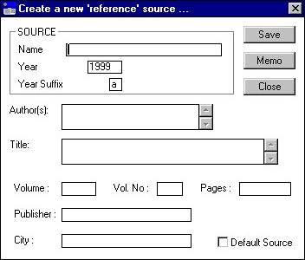
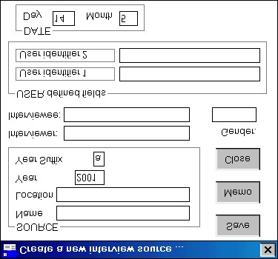
Figure 7.8a The interview dialog box Figure 7.8b The reference dialog box

The year suffix is to enable you to distinguish between multiple interviews (or multiple articles) by the same person within the same year.

If it is felt that more detail is needed either about the informant (for example, age, family background, ethnic group) or about the reference, then this information can be added by selecting Memo, and typing the information into the ‘Memo attached to source’ dialog box (Figure 7.9).

3 In the case of an article, the name of the journal should go in the ‘Name’ box.
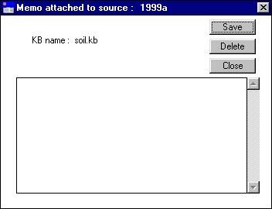
Figure 7.9 The ‘Memo attached to source’ dialog box, in which extra information about the informant or the reference can be added.

Editing an existing source
If entering new statements but from a source already in the data base, check that the correct source is highlighted and appears in the ‘Selected source’ box of the ‘Information Source’ dialog box as in Figure 7.10 below. Then press OK.

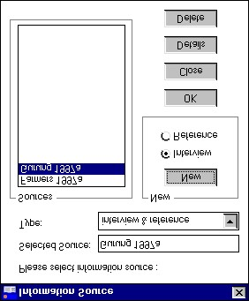

Figure 7.10 Highlighting a source already entered

Deleting a source

Sources are usually entered into the knowledge base when statements are being entered either via the Statements dialog or via the Diagram interface (see chapter 8) as a statement cannot be entered without a source (see above, 7.4.2). However, only one source per statement can be entered via the Statements menu (see above, 7.4.1), whereas there may be several sources for one statement. Additional sources can therefore be entered via Sources in the main KB menu.

The ‘Information Source’ dialog box is exactly the same as that entered via the Statements dialog (see 7.4.2). Figure 7.48 below is the ‘Information Source’ dialog box of the knowledge base, ‘treefodd’.

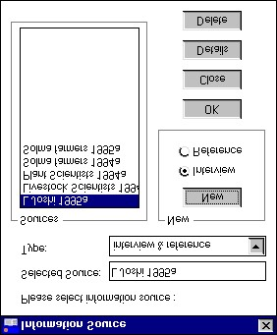

Figure 7.48 The ‘Information Source’ dialog box, entered directly via Sources in the main KB menu

The details of existing sources can be accessed via Details. New sources can be entered by highlighting the relevant radio button and pressing New. The two dialog boxes ‘Create a new ‘interview’ source’ and ‘Create a new ‘reference’ source’ function in exactly the same way as described in 7.4.2.

Sources can be deleted by selecting Delete. However, sources which are attached to statements can only be deleted if there is more than one source for that particularly statement.

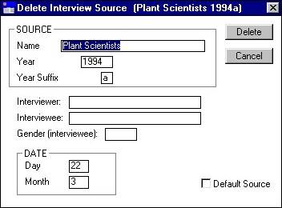
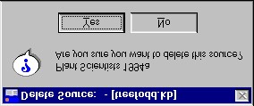

Figure 7.50 The second step in deleting a source

Figure 7.49 The first step in deleting a source

Figures 7.49 to 7.51 describe the steps taken to delete the source ‘Plant Scientists 1994a’ from the knowledge base ‘treefodd’. ‘Plant Scientists 1994a’ is the sole source for some of the statements within the knowledge base. For this reason the message appears saying that it cannot be deleted (Figure 7.51).

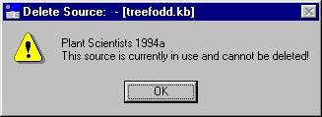
Figure 7.51 The message that appears if a source is the sole source for a statement and therefore cannot be
deleted.

KB > Formal terms: Viewing, creating and editing formal terms (list interface)

Statements are made up of two types of words. The first are keywords which are part of the AKT language, such as “att_value”, “if” and “causes1way”. The others are “formal terms”: words provided by the original source (perhaps moderated by the investigator) relating to specific aspects of their knowledge, such as the names of plants (such as “maize”, the names for attributes (such as “height”), and the values that attributes can take (such as “high”). In general, these are nouns, except for the values of attributes, which can be adjectives.

For the knowledge base to be useful, It is important that formal terms are consistent, and as unambiguous as possible. However, different users may have a different understanding or concept of the same term. For example ‘alley cropping’ may suggest to some a system where the tree component is made up of a single or multiple row of trees, whilst others envisage a system of dense hedgerows. For this reason it is useful to be able to define exactly what is meant by the term in the context of a specific knowledge base. This is the role of the “Definition” field for a formal term.

Conversely, there may be several words used for the same underlying concept, such as the local, English and scientific names for a plant, and even different local and English names. In order to cater for these, AKT5 (and hence webAKT) supports the notion of synonyms.

(From AKT Manual…)
The ‘synonyms’ option allows you to specify a synonym for a formal term. An example of this might be the local name for a plant beside the common English name and the scientific Latin name. For example, the tree with the common English name ‘shea butter tree’ has the scientific name Vitellaria paradoxa, and is also commonly known in English by its French name ‘karité’ whilst in the Hausa language in Nigeria it is known as ‘ka’danya’, in the Bambouk language in Senegal it is known as ‘toulou’. Thus a knowledge base developed on the shea butter tree in West Africa would need to record all the common synonyms for the tree.

The synonym could also be for a value such as ‘decrease’ for ‘decline’ or a process such as ‘furrowing’ for ‘ploughing’.

The reason it is important to have the synonyms option is that it permits you to draw on all available statements using the formal term or any of its synonyms and prevents accidental exclusion in a topic knowledge base because different terms have been used for the same object/process/value etc.

However, there are two major issues with synonyms in AKT5. The first is that synonyms are “second-class citizens”: they are not listed in the glossary of formal terms, and they are not apparent when you look at a statement. The second is that synonyms do not have a type (e.g. “english_name”, “scientific_name”). (They can be given a numeric order in the list of synonyms for a formal term, and that can be used as a sort of typing mechanism, but that is an obscure way of achieving this goal.)

Both of these limitations are being addressed in webAKT. This is still work in progress, but it will allow you to (for example) ask for a list of statements using the scientific name where possible; or mouse-over the terms in a statement to see the synonyms for each term; or see all synonyms listed when you ask for a list of formal terms.

Displaying all the formal terms (list format)

Formal Terms, under the main KB menu brings up a glossary for all the formal terms in the knowledge base. Selecting a formal term type (object, process, action, attribute, value, link and comparison) from the ‘Type’ box will bring up the glossary for that type (Figure 7.52). Unlike object hierarchies, this glossary is flat - simply an alphabetical list of terms. Foral terms are added to the glossary automatically during the process of entering a statement, or by the user explicitly creating a new formal term.

The Formal Terms panel has three parts to it.

The listbox
The main part is a listbox, listing all the formal terms, or a subset of them. This list is actually a table, with the additional column indicating the type of the formal term (e.g. object, attribute…). In future versions of webAKT, the columns will be customisable, allowing other properties, intrinsic or calculated, of the formal terms to be added to the table, such as the number of statements each one occurs in. Also, this list will be sortable by any of the columns.

The filter
At the top of the panel, a simple listbox enables you to select which type of formal term you want to be displayed.

The buttons
There are 4 buttons for working with an individual formal term:

View: To view the details of a selected formal term. First, select it from the listbox, then click this button.
New: Create a new formal term. Only use this if you want to ad terms instead or or before they are picked up from statements.

Edit: To view and potentially edit the details of a formal term, e.g. add a description or specify a synonym.

Delete: For deleting a formal term from the glossary of formal terms.

The first 3 buttons call up the same panel, the formal_term_details panel, the only difference being that it’s appearance and the operations you can perform are slightly different for each of the 3 modes.

Viewing a formal term
The details of each term can be accessed by selecting a term and clicking the View button. The ‘Formal Term Details’ dialog box (Figure 7.53) gives the formal term type, its definition and any synonyms there may be. If you select Show use in statements a dialog box ‘Search Results’ appears, giving all the statements in which the formal term appears (Figure 7.54). For objects it is also possible to select Show use in hierarchies. If the object appears in any hierarchies the relevant hierarchy names will appear (Figure 7.55). In the example below, the formal term ‘cattle’ appears in three formal statements and in the object hierarchy, ‘Livestock’.

Figure 7.52 Selecting the type of formal term in the Formal Terms dialog box

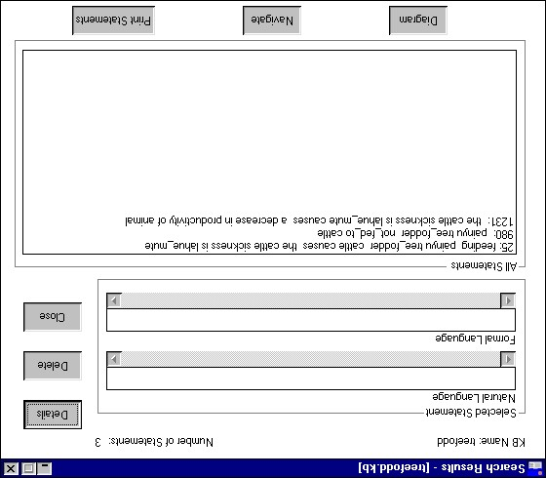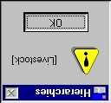

Figure 7.55

The
message
that
appears
having
selected
Show use
in hierarchies
in
Formal
the
Term
dialog
with
box,
‘cattle’ as the formal
term

Figure 7.54 ‘Search Results’ for the formal term ‘cattle’ – screen display after selecting Show use in statements in Formal Terms dialog box

Creating a new formal term

Normally, formal terms are created automatically, when you enter a statement, as described in the KB/Statements/Statement details section. To do this, webAKT analyses the grammatical structure of the statement to determine the grammatical type of each term (e.g. object, attribute, process…), and adds it to the formal terms glossary. You can then edit this entry to, for example, provide a description of, or synonyms for, this term.

However, it is also possible to add new formal terms, unattached to statements, to the formal term glossary. This is particularly useful for objects and object hierarchies, since you might want to build up a glossary of common terms before, or in parallel with, entering statements.

First, check the list of formal terms to see whether this term, or a suitable equivalent, already exists in the forma term glossary. If it doesn’t, click on the New button. This opens up a formal_term_details panel.

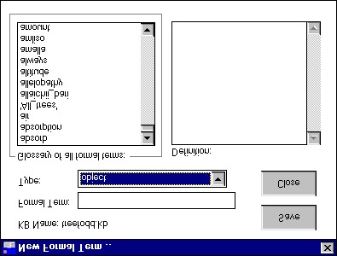

Figure 7.56 ‘New Formal Term’ dialog box

The new ‘Formal Term’ is typed into the top box. The ‘Glossary of all formal terms’ exists to enable you to check that the term, or something similar, is not already in the knowledge base. You select the formal term type from the drop-down menu in the ‘Type’ box. The ‘Definition’ box enables you to add a precise definition of the term as it is to be understood in the context of the present knowledge base.

When finished, press Save. A message will then appear, ‘Do you wish to add the formal term to the Kb?’ (as it does whenever you introduce a new formal term when you create a new statement). Press Yes, whereupon a message appears to confirm that the new term has been saved.

If you attempt to add a term which already exists in the knowledge base, a message appears ‘A term with the same name already exists in the kb’.

By pressing Save in the ‘New Formal Term’ box, you will only save the new term in the currently-loaded knowledge base, though this, like all other operations that change the knowledge base, is backed up (in what is called Local Storage) whenever you make a change, and will be re-loaded automatically when you re-visit webAKT. To save it permanently to file, it is necessary to select Save KB as under the main File menu, and select the file you want. For security reasons, JavaScript does not allow you to have a simple Save operation.

Editing a formal term

Deleting a formal term

These added terms may also be deleted by highlighting them in the ‘Formal Terms’ list and selecting Delete. However, it is not possible to delete a formal term that still appears in a formal statement. In order to remove a formal term which appears in a formal statement, the term must either be replaced, using the edit function in the Statements menu (see above, 7.4.4) or by deleting the statement altogether, using the Delete function in the Statements menu (see above 7.4.5).

Adding definitions to formal terms

In order to add definitions select Formal Terms in the ‘Edit statement’ dialog box (Figure 7.16 above) and the following screen appears (Figure 7.17);

The ‘Statement Formal Terms’ dialog box displays two lists, the first, headed ‘Statement Formal Terms’ gives a list of all the formal terms within that particular statement. By highlighting one of the terms, that term’s type (i.e. object, process, action, attribute, value, link or comparison) will be displayed in the ‘Type’ box. The second list, headed ‘Formal Terms’ gives a list of all the formal terms within the knowledge base. This serves as a reference and should be consulted so as to avoid unnecessary use of synonymous terms. In order to define any of the terms, highlight the required term, and select Details4 dialog box enables you to: . The ‘Formal Term Details’ dialog box will appear (Figure 7.18). The ‘Formal Terms Details’

- define the term by filling in the ‘Definition’ box;
- check whether the term has any synonyms;
- check in which statements the term has already been used by selecting Show use in statements; and
- check whether the term already appears in an object hierarchy by selecting Show use in hierarchies.

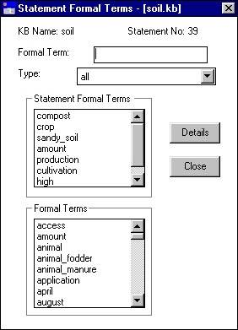
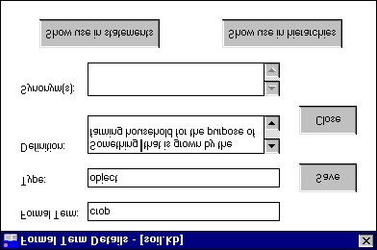

Figure 7.18 ‘Formal Term Details’ dialog box

Figure 7.17 The ‘Statement Formal
Terms’ dialog box

2
After editing a statement it is advisable to save the whole knowledge base through the main KB menu.
4 For a more detailed description of ‘Formal Term Details’ see section 7.7.

KB > Object Hierarchies

AKT allows you to generate one or more hierarchies of objects. In the context of AKT, an “object” is one type of formal term, and is the only type that can be organised in a hierarchy. This enables statements to refer to objects at different levels of generalisation. For example, a statement may refer to an object of type “grass”, and it is then relevant to all objects which are grasses, i.e. all objects below grass in the hierarchy. So, an AKT hierarchy is very similar to a plant or animal taxonomy, but extends the concept to other hierarchical relationships

A single knowledge base may contain a number of discrete hierarchies, and a single object may occur in more than one hierarchy. This might seem odd, but makes sense when we realise that we can have, for example, a “food” hierarchy, or a “weed” hierarchy, when the relationships are not simple taxonomic ones. So “maize” can be in a plant taxonomy hierarchy, and also in a food-type hierarchy.

The creation and manipulation of object hierarchies are controlled by the Object Hierarchies entry under the main KB menu.

If you are familiar with AKT5, then you will notice a substantial difference in the way that Object Hierarchies are displayed in webAKT. To illustrate the difference, the following screenshot shows the Crop object hierarchy in AKT5…

… and the same hierarchy as it appears in the object Hierarchy Details in webAKT. You can see that, in AKT5, the display shows the nodes (objects) which are above (superobjects) and below (subobjects) a particular object. This provides a very restricted view of the hierarchy. In webAKT, in contrast, the whole hierarchy is displayed as a collapsible tree, and the user can readily see how a particular node fits into the whole hierarchy. This is one of the bigger departures from the AKT5 way of doing things.

Listing all the object hierarchies
The Object Hierarchies panel is very simple, simply displaying a listbox containing the IDs of the current object hierarchies. If none currently exist, this listbox is empty.

The panel includes 4 buttons:

View – for displaying an object hierarchy selected in the listbox.
New – for creating a new object hierarchy.
Edit – for editing an object i selected in the listbox.
Delete – for deleting an object hierarchy selected in the listbox.

The first 3 of these all invoke the Object Hierarchy Details panel, whose appearance differs slightly depending on which of the 3 modes it is in.

Creating a new Object Hierarchy
A new object hierarchy is created by selecting New (Figure 7.27). In the new dialog box that appears, ‘New Object Hierarchy’ (Figure 7.28) a new hierarchy name has to be given. The ‘New Hierarchy Name’ can be either one of the objects which occurs in the unitary statements or it can be a completely new name, not directly related to any of the unitary statements but which provides a means of identifying the relationship between the other objects appearing in the hierarchy. Enter the name and press Save.

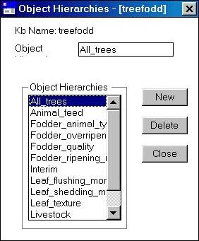
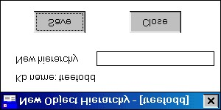

Figure 7.28 Dialog box for New Object Hierarchy

Figure 7.27 Dialog box for object hierarchies

Once a hierarchy name has been entered and saved, the dialog box will revert to the ‘Object Hierarchies’ dialog box with the new hierarchy name included in ‘Object Hierarchy’ list.

Viewing an object hierarchy

To view an object hierarchy, highlight the relevant hierarchy from the ‘Object Hierarchies’ list in the ‘Object Hierarchies’ dialog box and the object hierarchy details will appear automatically.

The screen below (Figure 7.29) is the ‘Object Hierarchy’ dialog box for the object hierarchy
‘Livestock’ in the ‘treefodd’ knowledge base. The left-hand side of the dialog box shows the ‘Objects in Hierarchy’ list, which is simply an alphabetical list of all the objects in the hierarchy. The central panel headed ‘Hierarchy Structure’ gives the structure of the hierarchy immediately above and below the selected object, with the selected object highlighted in the middle box under ‘Object’ and also in the ‘Selected Object’ box at the top, under the hierarchy name.

In Figure 7.29 the object in the ‘Selected Object’ box is Livestock. As that is also the hierarchy name, there are no objects listed in the SuperObjects box. In the ‘Immediate SubObjects’ box are listed ‘animal’ and ‘bird’. If we highlight another object in the ‘Objects in Hierarchy’ list, for example, ‘large_animal’, the objects in the ‘Hierarchy Structure’ section will automatically change to Figure 7.30. Now ‘animal’ appears as the superobject and ‘buffalo’ and ‘cattle’ as the immediate subobjects.

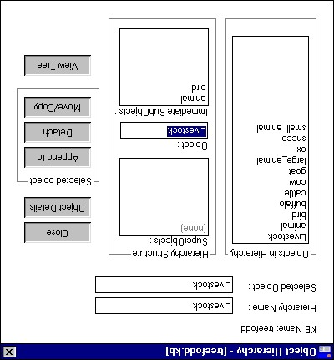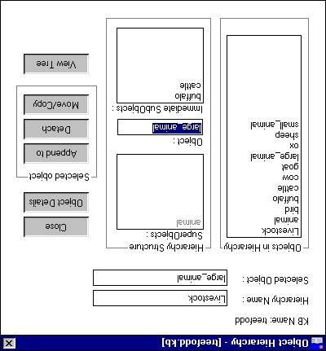

Figure 7.29 ‘Object Hierarchy’ dialog box Figure 7.30 Highlighting large_animal in the
‘Object’ box of the hierarchy structure.

To get a comprehensive view of the ‘Livestock’ hierarchy structure, select View Tree. The following diagram appears (Figure 7.31), the scroll bars enabling you to view the whole diagram. It is also possible to copy the hierarchy tree and paste it to another package, by pressing the Copy to Clipboard button. Open the package and paste the hierarchy tree immediately by selecting Edit and then Paste or by pressing Ctrl v.

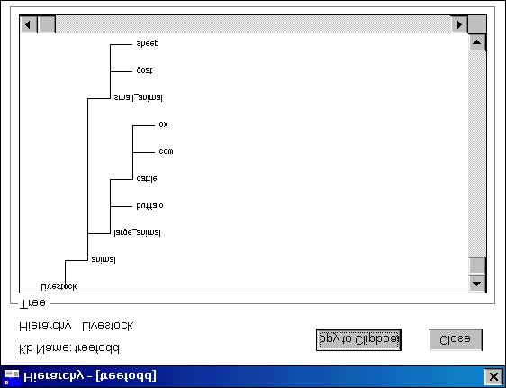

Figure 7.31 A diagram of the ‘Livestock’ hierarchy, generated by selecting View Tree

Building and editing an Object Hierarchy

Adding objects

To build up an object hierarchy, or to add to one already extant, highlight the relevant hierarchy from the ‘Object Hierarchies’ list and the ‘Object Hierarchy’ dialog box will automatically appear. Figure 7.32 is of the ‘Object Hierarchy’ dialog box for a newly created hierarchy with no objects attached.

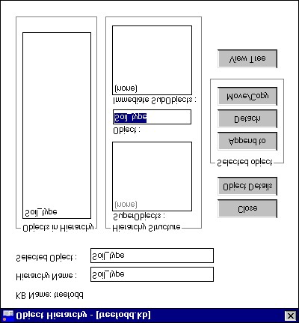

Figure 7.32 The ‘Object Hierarchy’ dialog box of a newly created object hierarchy

To add objects to a hierarchy, select Append to. The resulting screen (Figure 7.33) will offer you a list of all the objects in the knowledge base. Highlight the desired object under the ‘Objects’ list and select Append. The message ‘Object appended to Hierarchy’ will then appear (Figure 7.34) and the object will appear as an Immediate SubObject of the hierarchy root.
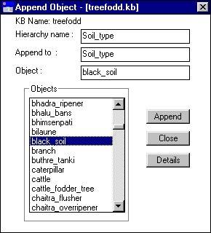
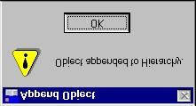

Figure 7.34 Message confirming that the object has been appended to the object hierarchy

Figure 7.33 Selecting an object to append to an object hierarchy

Any number of objects can be appended to the object hierarchy in this way, appending them one at a time.

The objects that appear in the object list (Figure 7.33 above) are taken from the statements entered onto the knowledge base. However it may be useful to add objects to the object hierarchy that do not appear in any of the statements but are implied by a more generic term. For instance, farmers may refer frequently to ‘livestock’, without mentioning the species. For the comprehensiveness and the power of the knowledge base it is nevertheless useful if the researcher can list the species kept, under a ‘Livestock’ hierarchy. To add objects that do not appear in the statements, you must first add them to the knowledge base as new formal terms (see 7.7.2) and then add them to the object hierarchy.

If you wish to create a hierarchic structure within the object hierarchy, then first select the root, or parent object from the list of objects. This object will then appear in the ‘Object’ box in the ‘Hierarchy Structure’ and objects can be appended to it as before. In Figure 7.35, black_soil is the head of the sub-hierarchy, and loose_soil is the new subobject.

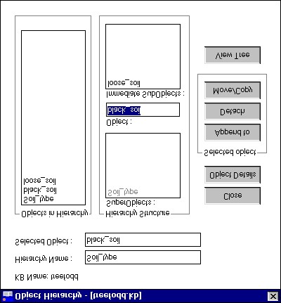

Figure 7.35 Demonstrating an object hierarchy, in which ‘black_soil’ is the selected object, ‘loose_soil’ its sub-object and ‘Soil_type’ its parent.

D

There are two ways of describing the position of an object in a hierarchy structure. Diagram A describes the position in its simplest form. All objects higher up the hierarchy than the object in question are superobjects, all those below are subobjects. A.
SUPEROBJECTS
Ç
OBJECT
È
SUBOBJECTS

But this structure can be defined more precisely in Diagram B. B.
ANCESTORS
Ç
PARENT
Ç
OBJECT
È
CHILDREN
È
DESCENDANTS

An object can only have one parent, or immediate superobject, but as many ancestors as there are rungs on the object hierarchy ladder above its own position on that ladder. On the other hand, an object can have many children, or immediate subobjects, and many descendants, on each rung below it on the hierarchy ladder.
Detaching objects

To detach an object from an object hierarchy, enter the relevant ‘Object Hierarchy’ dialog box and highlight the object to be detached in the ‘Objects in Hierarchy’ list. The object will then appear in the ‘Selected Object’ box and in the ‘Object’ box within the ‘Hierarchy Structure’. In Figure 7.36 this is the object ‘goat’. Then press Detach.

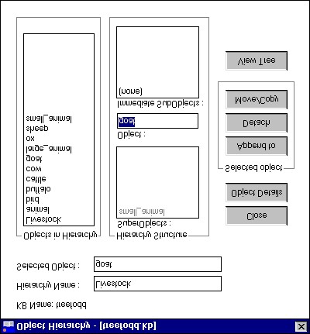

Figure 7.36 Detaching ‘goat’ from an object hierarchy

The following message appears (Figure 3.37) asking whether to detach the selected object. Press Yes and another message appears, confirming that the object ‘goat’ has been removed (Figure 7.38).

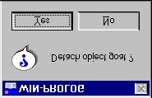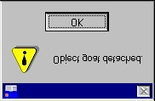

Figure 7.37 Message to confirm detaching Figure 7.38 Message confirming that the object object has been detached

The object ‘goat’ is now removed from the object hierarchy ‘Livestock’, although it still exists as a formal term in the knowledge base.

If you wish to detach an object which is the head of a sub-hierarchy, for instance ‘large animal’ in Figure 7.39, which has ‘buffalo’ and ‘cattle’ as sub-objects, once you have pressed Detach, and confirmed that the object is to be detached (as in Figure 7.37 above), a new message appears (Figure 3.40).

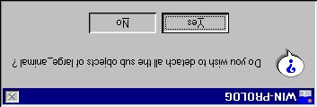

Figure 7.40

Message displayed when
detaching an object with sub-objects attached

Figure 7.39 Detaching an object with subobjects attached

The program asks whether or not you wish to detach all the sub-objects together with the selected object. If you press Yes then in this case ‘buffalo’ and ‘cattle’ will be removed from the object hierarchy as well. If you press No then another message appears (Figure 7.41), which confirms that the object has been detached and its sub-objects raised up a level within the hierarchy.

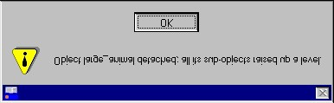

Figure 7.41 Message appearing if an object is detached but its sub-objects are left in place

Moving objects within a hierarchy

It may be necessary to rearrange an object hierarchy, moving objects to different levels within the hierarchy. In the below example, Figure 7.42, ‘chickens’, ‘ducks’ and ‘geese’ have been added to the Livestock hierarchy, and are directly below ‘Livestock’ on the hierarchy tree. However, it would be more appropriate to put them under ‘bird’. In order to do this highlight the first object, ‘chickens’, in the ‘Objects in Hierarchy’ list and press Move/Copy. The ‘Move Object’ dialog box appears (Figure 7.43).

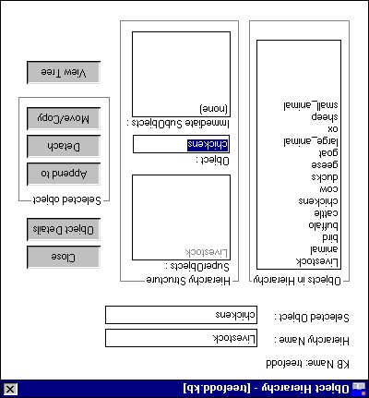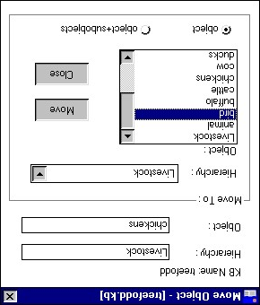

Figure 7.42 Highlighting an object before Figure 7.43 Moving an object to another part moving it within an object hierarchy of the object hierarchy

The ‘Move Object’ dialog box gives the name of the hierarchy in use (‘Livestock’), and the object to be moved (‘chickens’). The ‘Move To:’ section allows you to select the hierarchy to which is to be moved, and under ‘Object’ lists the objects within that hierarchy under which the object can be placed. At the bottom of the dialog box is the option to move, either just the object, or the object plus its sub-objects. In this case the object ‘chickens’ has no subobject, so the ‘object’ bullet is highlighted. Then press Move. The following message appears (Figure 7.44);

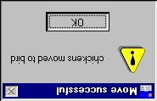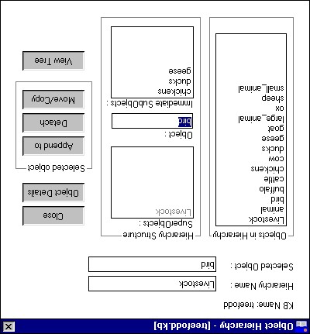

Figure
7.44

The
message
confirming an object has been
successfully moved within an
object hierarchy

Figure 7.45 An object (‘bird’) and its three immediate
subobjects (‘chickens’, ‘ducks’ and ‘geese’), after they have been moved within the object hierarchy.

Exactly the same procedure is carried out for ‘ducks’ and ‘geese’, so that all three are now subobjects of ‘bird’ as in the ‘Object Hierarchy’ dialog box in Figure 7.45.
Copying objects between hierarchies

It is possible to copy objects with or without their immediate sub-objects between different object hierarchies. To do this, follow the same procedure as above, highlighting the object to be copied in the ‘Objects in Hierarchy’ list in the ‘Object Hierarchy’ dialog box and press Move/Copy. In the example below, Figure 7.46, we are copying the sub-hierarchy ‘bird’ to the object hierarchy ‘Plant_pest’. In the ‘Move Object’ dialog box the present hierarchy name ‘Livestock’ is in the top ‘Hierarchy’ box. In the ‘Copy To:’ section the hierarchy ‘Plant_pest’ has been selected from the drop down menu. The objects in the ‘Object’ list are now all objects from the ‘Plant_pest’ hierarchy. Highlight the object under which the new object should be copied. In this case it is ‘crop_pest’ (Figure 7.47) Then select whether the object alone should be copied or the object plus its sub-objects by selecting the relevant radio button. In this case the subobjects of ‘bird’, ‘chickens’, ‘ducks’ and ‘geese’ cannot be described as crop pests, therefore the object ‘bird’ is moved alone, without its subobjects.

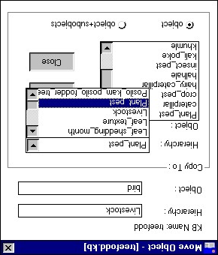
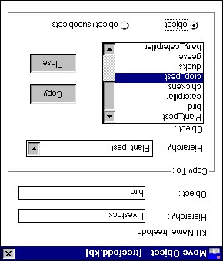
Figure 7.46 Selecting the new object Figure 7.47 Selecting the object under which hierarchy to which the object is to be copied the object to be copied is to appear

Then press Copy. The object is then automatically copied to the new object hierarchy.

2
It is only possibe to copy objects and objects + subobjects from one hierarchy to another, not to move them. If you want ot move them, copy the objects to the new object hierarchy and then detach them from the original object hierarchy as described in 7.5.3

KB > Boolean search: selecting a subset of statements

A key feature of AKT5, emulated in webAKT, is that it enables the user to extract subsets of the statements in a knowledge base according to user-specified search criteria. Often, this selection of subsets of the knowledge base may be a part of the process of evaluating and using the knowledge base.

The search is described as Boolean search because it enables search expressions to be formulated using the Boolean operators ‘and’, ‘or’ and ‘not’.

Currently, the search criteria are limited to formal terms which the statements may or may not contain. In future releases of webAKT, the criteria will be expanded to include other properties of the statements, such as its sources, its type (att_value or causal; unconditional or conditional), etc.

This section is included here, before the section on Topics, because an understanding of the Boolean search mechanism is essential to an understanding of how to define topics.

Boolean search

The Boolean Search offers a search criterium for creating subsets of knowledge. You can search for individual keywords, formal terms or sources. It is also possible to link any of these together using and and/or or, or even whole hierarchies or subsets of hierarchies, and then search for these. It is also possible to carry out a search combining formal terms with sources.

2
For demonstrating the functions available in the Boolean Search, we have used the knowledge base ‘soil’.

A Boolean search is carried out by selecting Boolean Search under the main KB. A ‘Boolean search’ dialog box appears (Figure 7.61).

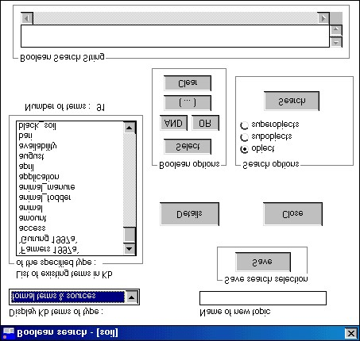

Figure 7.61 The ‘Boolean Search’ dialog box

The ‘Display KB terms of type’ box will give you the option of selecting one of the seven formal term types as well as sources, synonyms and topics. Highlight the type required. The ‘List of existing terms in KB of the specified type’ below will display all the terms under that type.

To conduct a Boolean search, highlight the term you wish to incorporate from the ‘List of existing terms in KB of the specified type’ box and press Select from the ‘Boolean options’ box. The chosen word will appear in the ‘Boolean Search String’ box at the bottom of the dialog box. The search is carried out by pressing Search in the ‘Search options’.

The use of ‘and’ and ‘or’.

Further terms can be added to a Boolean Search String by clicking on and or or and then highlighting the next term and pressing Select again. The option and narrows a search by limiting the search to only those statements that contain all the terms selected. The option or broadens the search by including all statements that contain one or more of the formal terms selected.

The use of brackets

If you use both and and or in your Boolean Search String, you must use brackets to construct the arguments logically, as one would in algebra. Using the knowledge base ‘soil’ imagine you wished to conduct a search which gave you all statements about degradation and soil and all the statements about erosion and soil. To do this you would use brackets in the Boolean Search String in the following way:

(degradation and soil) or (erosion and soil) (Figure 7.62)

Studying the ‘search results’ using ‘Diagram Selection Type’

Once you have formulated the Boolean Search String and pressed Search, the resulting popup menu, the ‘Search Results’, displays all the statements found by the search (Figure 7.63).

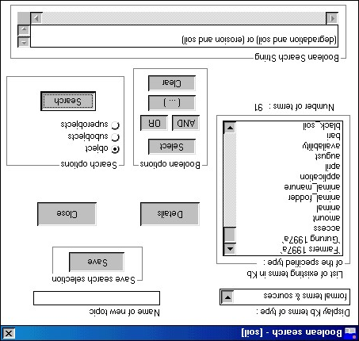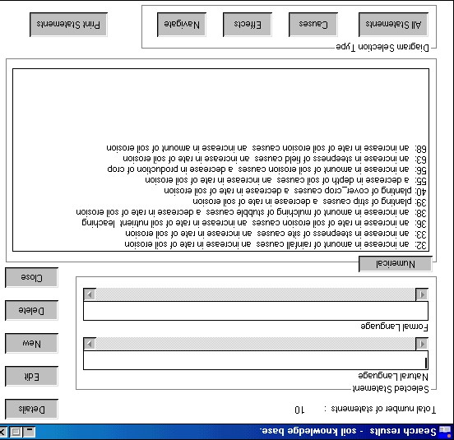

Figure 7.62 Carrying out a Boolean Search in ‘soil’ Figure 7.63 Search results from the Boolean Search in Figure 7.62

The following is text from the AKT5 manual at this point. It refers to the use of diagramming for displaying the results of search that can be displayed as a causal network. I will replace that by a simple sentence saying that such displays of search results will be presented in the Diagramming section of this manual.

If you press Diagram in the ‘Search Results’ dialog box, a diagram of all the statements from that search, which can be diagrammatically represented, appears (Figure 7.64). (See Chapter 8 for further details about the diagramming interface).

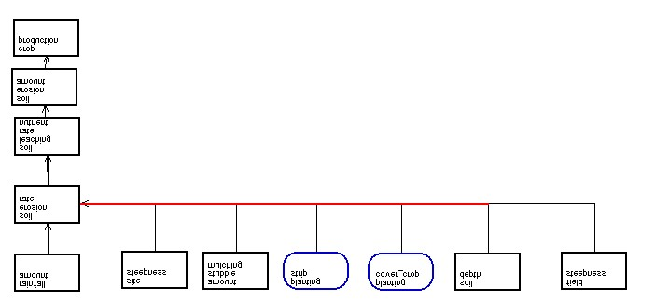

Figure 7.64 The diagrammatic representation of the Search Results in Figure 7.63

It is also possible to highlight any one of the statements in the ‘Search Results’ and then click on Navigate. This option will give you all the immediate causes and effects associated with that particular statement. Figure 7.65 gives a diagrammatic representation of all the nodes immediately associated with statement no.32 in the ‘Search Results’ (see Figure 7.63 above) - ‘an increase in amount of rainfall causes an increase in rate of soil erosion’.

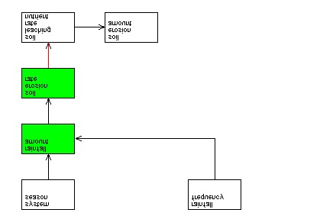

Figure 7.65a The diagrammatic representation of all the causal statements immediately connected to Statement No.32 ‘an increase in the amount of rainfall causes an increase in the amount of soil erosion.’

By selecting Statements on the left-hand side of the Diagram screen (see Chapter 8), you will get a full list of the statements incorporated into the diagram (Figure 7.65b)

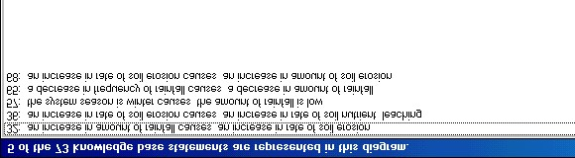

Figure 7.65b Statements incorporated in the diagram in Figure 7.65a

It is also possible to use the Causes and Effects buttons. In the following example we have highlighted the same statement as above, statement no. 32 ‘an increase in amount of rainfall causes an increase in rate of soil erosion’ and then pressed Causes. The diagram in Figure 7.66a depicts the causes that flow into statement no.32 and Figure 7.66b presents them in list form.

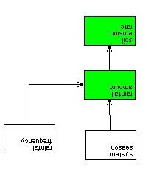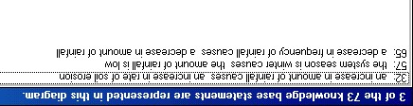

Figure 7.66b
List of statements represented in Figure
7.66
a

Figure 7.66a Causal flow into
Statement No.32

Using the same statement no. 32 once more we pressed Effects. Figure 7.66c is a diagram of all the effects flowing from the statement no. 32 and Figure 7.66d presents them in list form.

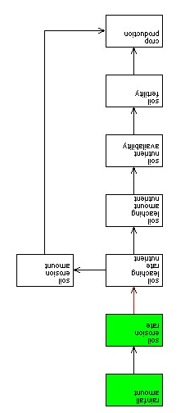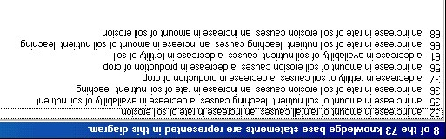

Figure 7.66d
List of statements represented in Figure 7.66c

Figure 7.66c Causal flow out of statement no. 32

D
To summarize ‘Diagram Selection Type’

All Statements– gives you a diagram of all the statements extracted by the Boolean Search which can be presented in diagrammatic form (i.e. causal and link statements)

Causes – gives you a diagram of all the causes of one statement selected from the statements extracted by the Boolean Search.

Effects – gives you a diagram of all the effects of one statement selected from the statements extracted by the Boolean Search.

Navigate – gives you a diagram of all the immediate causes and effects of one statement selected from the statements extracted by the Boolean Search.

Using Boolean search on object hierarchies

For the objects amongst the formal terms selected in the ‘Boolean Search String’, a choice of search modes is available in the ‘Search options’ box; ‘object’, ‘subobject’ and ‘superobject’ (see above, Figure 7.62). By highlighting one or more of these options there are 7 possible combinations for the Boolean search. For example ‘object’ alone recognises only those statements in which the object selected is actually used; ‘object’ plus ‘subobject’ extracts unitary statements in which either the specified object or the children and descendants of that object in the object hierarchy are used; and ‘object’ plus ‘subobject’ plus ‘superobject’ extracts unitary statements in which either the specified object, its children and descendants, its parent, or ancestors all the way up the hierarchy tree, are used.

The collection of statements displayed as a result of a Boolean Search will assist in the interactive evaluation of the knowledge base contents, but it is worth noting that all of these search facilities can be invoked by one or more of the primitive tools (see chapter 9).

KB > Topics

Creating a new topic

It is possible to save any combination of search criteria to gather all the information about a particular topic within a knowledge base. To create a topic, first select your search criteria for the Boolean Search String, as described above (7.10.1). Then enter a topic name in the ‘Name of new topic’ box in the ‘Boolean Search’ dialog box (Figure 7.67) and press Save. The ensuing menu, ‘Topic details’ will permit you to add a description of the topic (Figure 7.68).

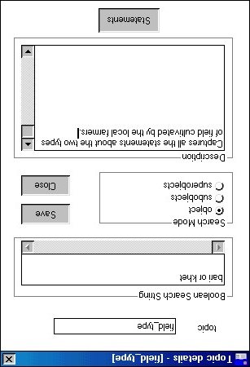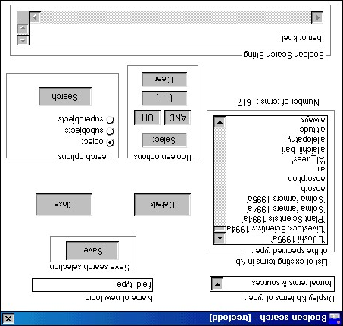

Figure 7.67

Creating a topic

Figure 7.68 Filling in the ‘Topic details’ dialog box

If the search string incorporates hierarchic objects then the ‘Search Mode’ will allow you to specify further search criteria. Once you have filled in all the details, press Save. A message will appear (Figure 7.69) confirming that the topic has been saved.

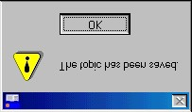

Figure 7.69 Message confirming that a new topic has been saved

Once you have pressed OK the screen reverts back to the ‘Boolean Search’ dialog box.

Editing topics

To manage topics already created, it is necessary to select Topics from the main KB menu. The following dialog box then appears (Figure 7.70);

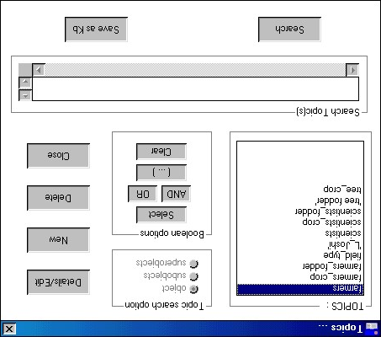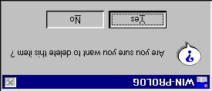

Figure 7.71

Message to confirm
that the alias is to be deleted

Figure 7.70 Topics dialog box

To see the details of a topic or to edit a topic, highlight the topic and press Details/Edit. This will bring up the ‘topic details’ box (see above 7.11.1 and Figure 7.68) which gives the Boolean Search String it uses, the search mode for objects and a description of the topic. If you wish to amend the details, it can be done from this dialog box, pressing Save when the amendments are complete. If you just wish to view the details, press Close when you have finished.

It is also possible to create a new topic by selecting New. If you select New the ‘Boolean Search’ dialog appears as above (see 7.10.1). To see the statements attached to a topic highlight the topic in the ‘Topics’ box, press Select so that the topic appears in the ‘Search Topic(s)’ box and then press Search. This brings up the ‘Search Results’ dialog box listing all the statements captured by that topic.

If you wish to delete a topic , you must first highlight the topic in the ‘Topics’ list and then press Delete. A message will then appear to confirm whether you want to delete the topic (Figure 7.71). Press Yes to confirm.

Using topics in search expressions

It is possible to search for several topics at a time. If you wish to see statements of more than one topic, highlight the desired topics one at a time, press Select and then press or before adding another topic to the ‘Boolean Search String’. If you wish to find only the statements which appear in two or more topics, use and to link the topics.

The ‘Topic Search Option’ box shows what combination of object, subobjects and superobjects was used to create the topic. This cannot be altered from within the ‘Topics’ dialog box. To alter the combination, you must press Details/Edit and revert to the ‘Boolean Search’ dialog box and alter it there.

Figure 7.72 is an example of combining two topics using OR. The two topics chosen were SoilColour and SoilTexture. The ‘Boolean Search String’ at the bottom of the dialog box gives the two topic names chosen. Once the selection is made, press Search and the ‘Search Results’ dialog box appears (Figure 7.73).

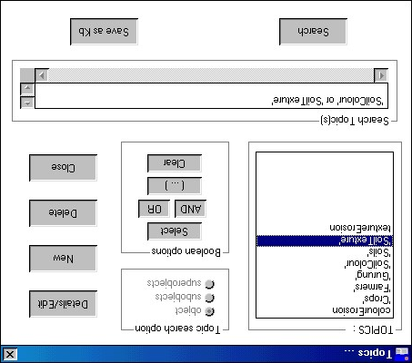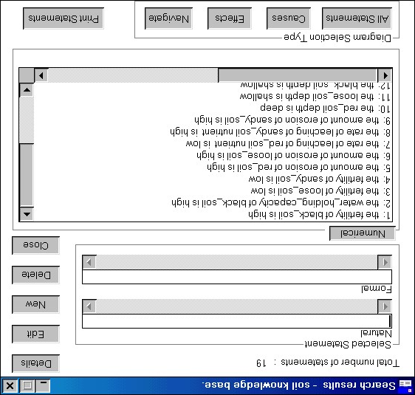

Figure 7.72 Boolean Search String for two topics Figure 7.73 The ‘Search Results’ dialog box for the combined, SoilColour and SoilTexture Boolean Search String in Figure 7.69

Creating a new knowledge base out of a topic

Note: This feature is currently not implemented in webAKT. I would like some indication from the AKT team as to whether this is a necessary/desirable feature – has it even been used?
The text below is unchanged from the KT5 Manual.

It is also possible to convert a topic, or a string of topics into a new knowledge base. This option is of use if the original knowledge base has become too large and unwieldy, or if so much information exists on a specific topic that it justifies creating a new, separate knowledge base. It may also be the case when a knowledge base is to be divided up between researchers, each with a separate remit, to study one particular aspect of the mother knowledge base.

In order to do this, highlight the topics you wish to incorporate into the new knowledge base - for this reason it is possible to highlight several topics at once. Then press Save as KB. This brings you to the ‘Name of new KB’ dialog box (Figure 7.74) where you can save the topics as a knowledge base under a new name and under a new folder/directory if necessary.

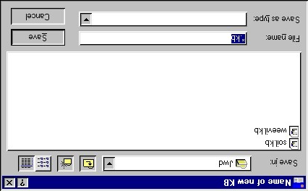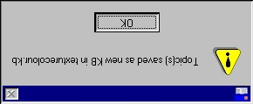

Figure 7.75

Message to confirm that
the topics have been saved as a new
knowledge base

Figure 7.74 ‘Name of new KB’ dialog box

Once you have entered a name for the new knowledge base and pressed Save, the screen reverts to the original knowledge base and a message appears that the topics have been saved as a new knowledge base (Figure 7.75).

Points to watch when converting a topic into a separate knowledge base

When you convert a topic or group of topics into a new knowledge base the new knowledge base will contain all the sources and all the object hierarchies and topic hierarchies which appeared in the original knowledge base. Only the formal terms that appear in the statements transferred to the new knowledge base and any object formal terms used by any of the hierarchies, will appear in the Formal Terms list.

Before embarking upon expanding the new knowledge base it would be wise to check rigorously whether all the sources, terms and hierarchies inherited from the original knowledge base are relevant to the new knowledge base. Certain elements may need to be removed to avoid confusion and to uphold the principle of parsimony.

KB > Topic Hierarchies

As one can have object hierarchies, so one can create topic hierarchies. A single knowledge base may contain a number of discrete topic hierarchies and a single topic may appear in more than one hierarchy. When you first open your knowledge base the ‘Topic Hierarchies’ dialog box can be accessed directly via the Welcome Memo by pressing the Topics button. This is to give the user an idea of what topics are covered by the knowledge base. If you wish to return to it later, you enter Topic Hierarchies via the main KB menu.

Viewing topic hierarchies

In order to view a topic hierarchy, enter Topic Hierarchies via the main KB menu. The ‘Topic Hierarchies’ dialog box appears listing the topic hierarchies that exist. If you highlight one of the topic hierarchies, the ‘Topics in selected hierarchy’ box produces a list of topics within the topic hierarchy (Figure 7.76).

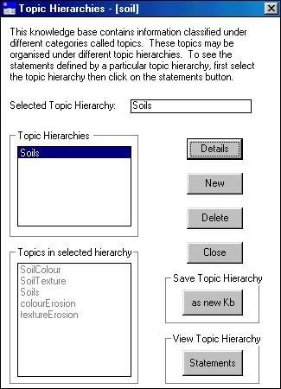
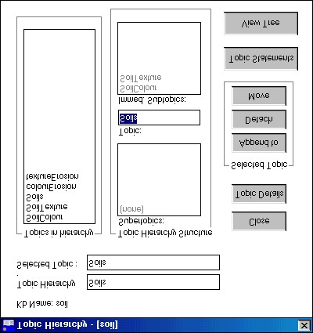

Figure 7.77 ‘Topic Hierarchy’ dialog box

Figure 7.76 ‘Topic Hierarchies’ dialog box

The relevant ‘Topic Hierarchy’ dialog box (Figure 7.77) appears automatically when you highlight a topic hierarchy in the ‘Topic Hierarchies’ dialog box and is very similar to the ‘Object Hierarchy’ dialog box explained above (see 7.5.2 and compare with Figure 7.29).

The Topic Details allows you to see the ‘Topic Details’ dialog box giving the Boolean Search String that made up the topic hierarchy, the search mode for objects and any description that might have been written on the topic hierarchy.

Topic Statements allows you to see and browse all the statements encompassed in the topic hierarchy. View Tree allows you to see the structure of the topic hierarchy.

Creating a new topic hierarchy

In order to create a new topic hierarchy, select New in the ‘Topic Hierarchies’ dialog box (see above, Figure 7.76). A ‘New Topic Hierarchy’ dialog box appears (Figure 7.78).

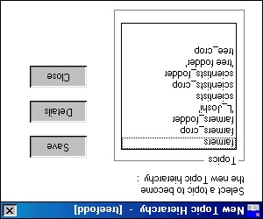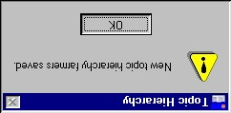

Figure 7.79

Message confirming that a new
topic hierarchy has been saved

Figure 7.78 ‘New Topic Hierarchy’ dialog box

Unlike Object Hierarchies where it is possible to create a new name for the hierarchy, the name of the new Topic Hierarchy must come from one of the topics already created. Highlight the chosen topic in the ‘Topics’ box. If you want to make sure how the topic was originally defined, (i.e. the Boolean Search String used), select Details. After checking the details, press Save. A message will appear, confirming that a new topic hierarchy has been saved (figure 7.79) and the topic name will now appear in the ‘Topic Hierarchies’ list of the ‘Topic Hierarchies’ dialog box (Figure 7.80).

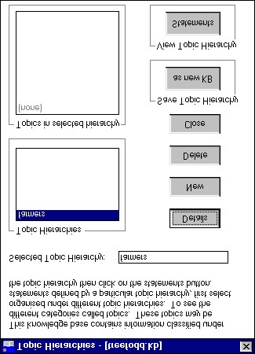

Figure 7.80 The new topic hierarchy appearing in the ‘Topic Hierarchies’ list box

To view all the statements, which form part of the topic hierarchy, select Statements. This will bring up a ‘Search Results’ dialog box with all the statements in the topic hierarchy listed in natural language.

To delete a topic hierarchy, highlight the relevant one and press Delete. A message will appear confirming that the topic hierarchy has been deleted.

Editing a topic hierarchy

In order to append topics to a topic hierarchy, highlight the chosen topic hierarchy in the ‘Topic Hierarchies’ dialog box. In the new dialog box ‘Topic Hierarchy’, select Append. An ‘Append Topic’ dialog box will appear (Figure 7.81)

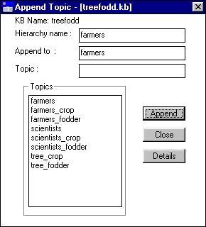
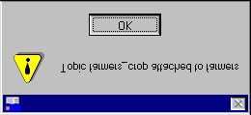

Figure 7.82 Message confirming that the topic has been appended to the topic hierarchy

Figure 7.81 ‘Append Topic’ dialog box

Select the chosen topic to be appended and press Append. A message will appear confirming that the topic has been appended to the topic hierarchy (Figure 7.82). In the example used here, a topic hierarchy ‘Farmers’ was created in the ‘treefodd’ knowledge base, to which the topics ‘farmers_crop’ and ‘farmers_fodder’ were appended. The ‘Topic Hierarchy’ dialog box gives the structure of the hierarchy (Figure 7.83).

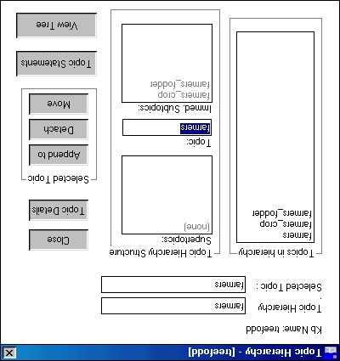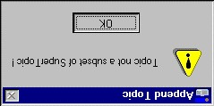

Figure 7.84
Message appearing when
it is not possible to append a topic to a
topic hierarchy.

Figure 7.83 The subtopics ‘farmers_crop’ and ‘farmers_fodder’ appended to the topic hierarchy ‘farmer’

Topics can only be appended to a topic hierarchy if they are a subset of that topic hierarchy. In other words their ‘Boolean Search String’ can only contain formal terms/sources also included in the topic hierarchy. In this case’ farmers_crop’ and ‘farmers_fodder’ are both subsets of ‘farmers’.

If you attempt to append a topic with a ‘Boolean Search String’ which is not a subset of that of the super-topic, for instance, if we try to append ‘scientists’ as a sub-topic of ‘farmers’, a message will appear warning you that the topic is not a subset of the super-topic (Figure 7.84).

Creating a knowledge base out of a topic hierarchy

Just as one can save a topic as a new knowledge base, it is also possible to save a topic hierarchy as a new knowledge base. In order to do so, highlight the topic hierarchy in question in the ‘Topic Hierarchies’ dialog box, and select as new KB from the ‘Save Topic Hierarchy’ box. The procedure is then identical to that of saving a topic as a new knowledge base (see above 7.11.4).

Unused text from the AKT5 manual

DIAGRAMMATIC REPRESENTATION

At the bottom of the Statement card are various options for diagrammatic representation (Figure 7.26).

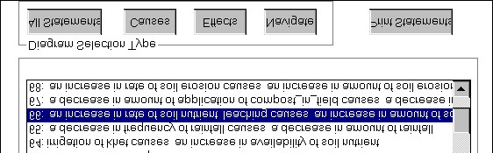

Figure 7.26 The diagram options at the bottom of the Statements card

If you select All Statements it will give you a diagram of all the causal and link statements in the knowledge base.

If you highlight a statement and press Causes it will give you a diagram showing all the connections (i.e. causes) flowing into the selected statement. If you highlight a statement and press Effects it will give you a diagram showing all connections (i.e. effects) flowing out of the selected statement. If there are no causes or no effects of a particular statement a message will appear to inform you of the fact.

If you highlight a statement and press Navigate, it will give you a diagram of the immediate causes and effects of the selected statement, from which you can build up the diagram further from within the diagram interface. Diagrammatic representation is dealt with in detail in Chapter 8.

base was 756, the number allocated to a new statement is 918. That means 162 inverse statements have been created after loading the original knowledge base.

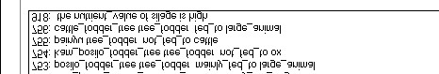

Figure 7.26a Demonstrating the gap between the last number of the visible statements and the first number of any new statements. The difference (162) is taken up by a set of invisible inverse statements.

PRINTING AND SAVING SEARCH RESULTS

In many cases it may be desirable to print out or to save search results made via the Formal Terms or Boolean Search dialog boxes. In order to do so, press Print Statements at the bottom of the ‘Search Results’ dialog box (Figure 7.85). A message appears (Figure 7.86) asking whether you wish to save the output to a text file.

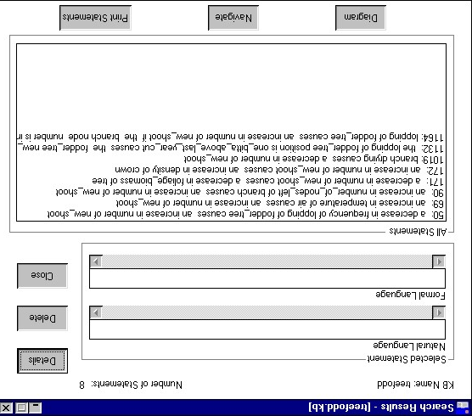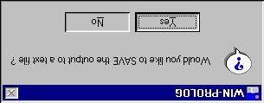

Figure 7.86
Message which appears
when you select
Print Statements

Figure 7.85 ‘Search Results’ dialog box for the formal term
‘new_shoot’

If you select Yes then the following ‘Save output in file’ screen will appear (Figure 7.87);

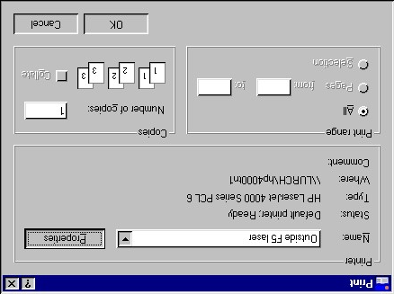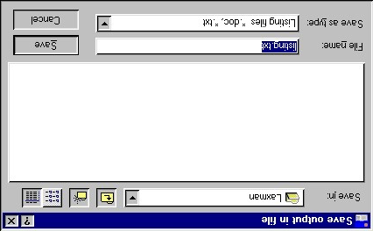

Figure 7.87 Saving the Search Results statements Figure 7.88 ‘Print’ dialog box
to a file

This allows you to save the text as a text file in a directory and folder of your choice. Once you have named the file and saved it in the correct place, press Save.

If you decide not to save the file and press No in Figure 7.86 above, the printer details dialog box will appear, allowing you to change its properties before printing.

PRINTING IN LANDSCAPE

If the statements are particularly long, it may be better to print out the statements in landscape. In order to do so, select Properties and then Basics from the printer details dialog box (Figure 7.89) and select the Landscape radio button under ‘Orientation’. Then press OK. This will return you to the ‘Print’ dialog box as above (Figure 7.88).

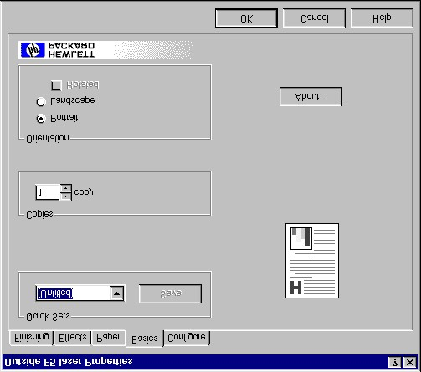

Figure 7.89 Selecting the Landscape option in print ‘Properties’

SAVING A KNOWLEDGE BASE

Saving a knowledge base on the hard drive
If you wish to save any additions or alterations to a knowledge base you have made since creating it or opening it, you must always select Save KB before you close the knowledge base down by selecting Close KB.

Saving a knowledge base to a floppy disk or a cd
If you wish to save a knowledge base to a floppy disk or cd, do not save it directly to the disk because it will take a very long time. Save it to the hard drive first and then, using Windows Explorer, select the saved file, press Ctrl c, open the floppy disk drive / cd drive and press Ctrl v.

Saving the knowledge base under a different name
If you want to change the name of a knowledge base, or create two versions of a knowledge base, then before closing the knowledge base you should select Save KB As. This allows you to rename the knowledge base and retain the original version, by giving the most recent version a new name, or to save the knowledge base in another folder or directory.

1WARNING
If you decide to change or edit the name of any knowledge base, it must only be done from within AKT via the Save KB As option. If it is done any other way then AKT will not be able to load the knowledge base correctly.

MOVING FROM ONE KNOWLEDGE BASE TO ANOTHER

It is possible to load more than one knowledge base onto the program at a time. The advantage of this is that it enables you to switch quickly from one knowledge base to another, without exiting the program, something which is of particular value when running the tools (see Chapter 9).

In order to load the knowledge bases onto the program, simply select Open KB from the main KB menu, and then choose the knowledge base you want. You load the knowledge bases one at a time, selecting Open KB each time. The most recent knowledge base to be loaded will be the one that appears on the screen. To move from one knowledge base to the other select Select KB from the main KB menu. The following dialog box appears (Figure 7.90).

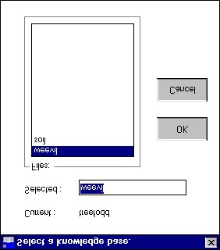

Figure 7.90 Moving from one knowledge base to another.

In this example the current knowledge base is ‘treefodd’. The other two knowledge bases loaded, ‘weevil’ and ‘soil’, appear in the ‘Files’ list. To change the current knowledge base, highlight one of the knowledge bases in the ‘Files’ list and press OK. The selected knowledge base will now automatically become the current knowledge base.

